**MINI PROJECT – I**

**(2017- 18)**

**Google Drive Client**

**SYNOPSIS**

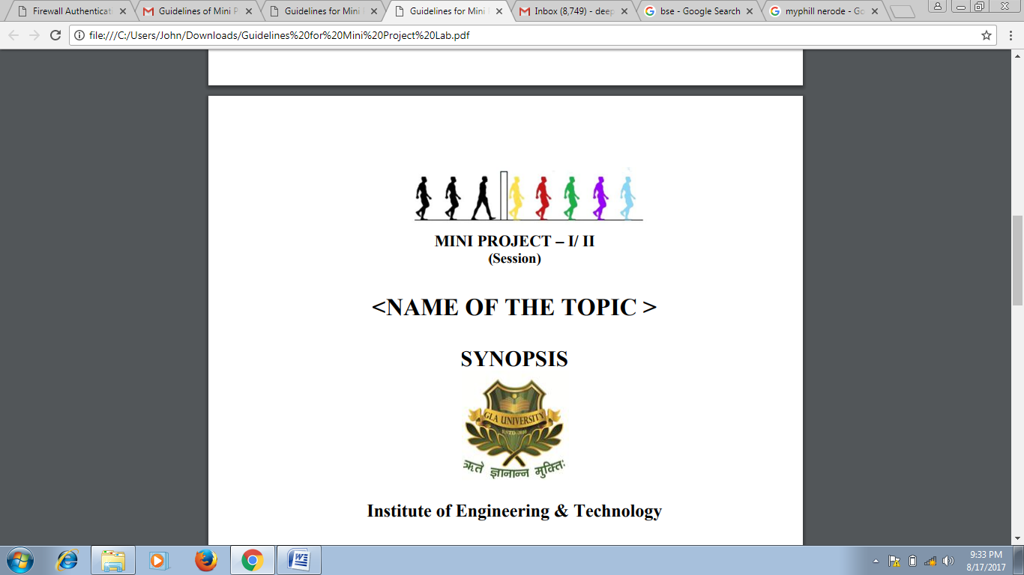

**Institute of Engineering & Technology**

**Team Members**

Prateek Agrawal(151200276)

Shalabh Chaudhary(151500470)

**Supervised By**

Name of Supervisor

Mr. Saurabh Singhal

Department of Computer Engineering & Applications

**Group Information:**

* Name : Prateek Agrawal

Class Roll no : 61

Mobile Number : +91 7464847884

Email Id : [prateek.agrawal_me15@gla.ac.in](mailto:prateek.agrawal_me15@gla.ac.in)

* Name : Shalabh Chaudhary

Class Roll no : 45

Mobile Number : +91 9457523332

Email Id : [shalabh.chaudhary_cs15@gla.ac.in](mailto:shalabh.chaudhary_cs15@gla.ac.in)

**Project Proposal:**

This is a client for Google Drive. This application will be cross platform. Google.lnc has not provided any client for Google Drive for Linux platform till now. A package will be provided to user and user need to install it. After installing, a folder named Cloud Drive will be created in home folder (In Linux), a folder will be added to quick access (in Windows). User need to sign up or sign in to his Google account and application will have access of his Google drive to update, delete, add the files on cloud.

Python3 and Pip must be preinstalled on the operation system. The user needs to give exception in firewall (if any) and the system must support to network connections and HTTPS protocol.

All offline available files will be automatically synchronized to his Cloud Drive folder and the newly created files or folder will be uploaded to cloud. Synchronization will be done automatically when the device will be connected to internet.

It can run on the following operating systems:

* Linux
* Windows

**Technologies Used:**

* Qt5
* Python3.6
* Scripting

**Libraries Used:**

* [PyQt5](https://pypi.python.org/pypi/PyQt5)
* [Pyuic5](http://pyqt.sourceforge.net/Docs/PyQt5/designer.html)
* [Httplib2](https://github.com/httplib2/httplib2)
* [Uritemplate](https://github.com/sigmavirus24/uritemplate)
* [Google api Python client](https://github.com/google/google-api-python-client)
* [Pycrypto](https://pypi.python.org/pypi/pycrypto)
* [Webtest](http://webtest.pythonpaste.org/en/latest/index.html)
* [Pyopenssl](https://pypi.python.org/pypi/pyOpenSSL)

**Broad Requirements:**

**OS:** Linux

**IDE:** Jetbrains Pycharm

________________________________________________________________________